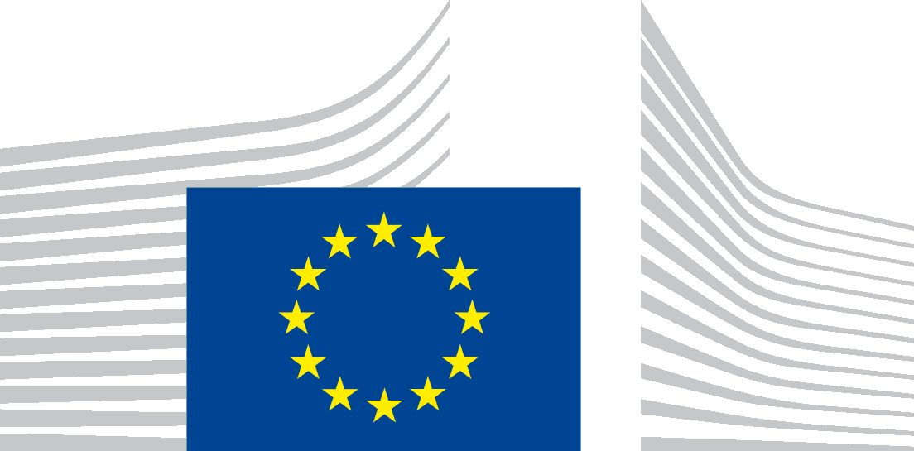 | EUROPEAN COMMISSION  DIRECTORATE-GENERAL MIGRATION and HOME AFFAIRS  Directorate E : Migration and Security Funds; Financial Resources and Monitoring  Unit E.3: National Programmes for North and West Europe; Evaluations; MMF
Brussels,
HOME/E3/StH
Ms Tairi Pallas
Estonian Ministry of the Interior
Pikk 61 15065 Tallinn
Estonia
Subject: Mid-Term Review – ISF National Programme – finalisation of the exercise
Dear Ms Pallas,

I would like to thank you for the fruitful discussions in the framework of the mid-term review of the ISF National Programme (NP), which allowed us to identify the policy priorities and the implementation issues to be addressed during the remaining period of implementation of the NP.

As regards ISF-Borders and Visa, the NP needs to be revised to include the extra allocation foreseen under the mid-term review (Article 6.1(c) of Regulation (EU) No 515/2014)). Please note that, following a budgetary reinforcement, the amount to be added to the NP is 1.959.416 EUR, (instead of 1.581.191 EUR as communicated in the note to the Members of the AMIF/ISF Committee (ref. AMIF-ISF/2017/20)).

Further to our exchange of letters and videoconference held on 13 February 2018, we would propose that the extra allocation is used to continue on the objectives in the national programme and to the implementation of EES and ETIAS.
We invite you to revise your national programme in SFC2014 accordingly and submit the revision as soon as it is approved by the Estonian government to allow for the approval of the revised programme and the commitment of the related funds timely within the budgetary year 2018. Besides the descriptive part, please be reminded to update the indicative timetable under section 3, the common indicators as applicable under section 5 and the financing plan under section 7.

Please bear in mind that, as already communicated previously, additional funding may become available later this year under the ISF Borders and Visa NP, notably for the implementation of the different IT systems such as Entry-Exit-System (EES).

As regards ISF-Police, and considering that no extra funding is foreseen for the moment in the framework of the mid-term review, we would recommend, as discussed, that Estonia fully exploits the resources available under the NP to adequately cover the relevant policy priorities, including through a revision of the NP, if necessary. However it would be an opportune moment to review the targets for the common indicators and the timetable of projects.

Please be informed that the Commission will include an assessment of the mid-term review in the interim evaluation report on the implementation of AMIF and ISF to be submitted to the European Parliament, to the Council, to the Economic and Social Committee and to the Committee of the Regions by 30 June 2018.

I hereby propose to conclude this mid-term review exercise and I would like once again to thank you for the fruitful cooperation.

The responsible desk officer, Stephanie Hardy(Stephanie.hardy@ec.europa.eu), remains at your disposal for any further clarifications that might be necessary.

Yours sincerely,

[e-signed]
Francisco GAZTELU MESQUIRIZ Head of Unit

Contributions from Norway, Iceland and Lichtenstein following the signature of the respective agreement on their contribution to the ISF-Borders and Visa instrument. The procedure for the agreement with Switzerland is still on-going.
Mid-Term Review ISF– Needs Assessment follow-up, 11 January 2018, Ares(2018) 180713

